**AWS Accounts** Creating an AWS Free tier account <https://www.youtube.com/watch?v=z95MhW1gAcA&list=PLuVH8Jaq3mLszrC7lv68a0VcrDripW-HK> 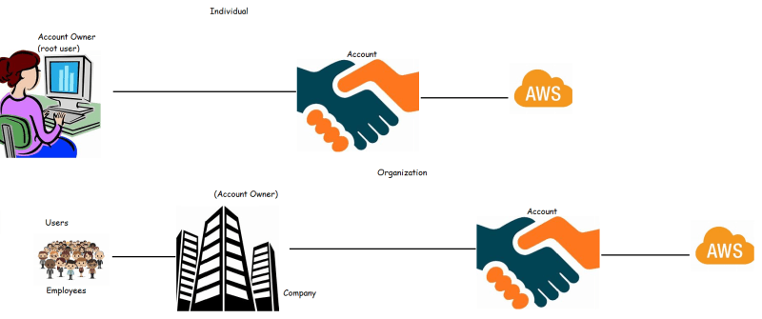

AWS offers Free tier account <https://aws.amazon.com/free/> where some services

are free for 12 months

are free for life time

are charged

**Identity in AWS**

In AWS, to authenticate and authorize we have a service which is called AWS Identity and Access Management (IAM) 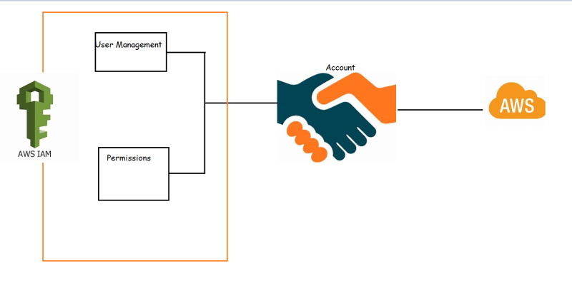

Different Ways of using AWS 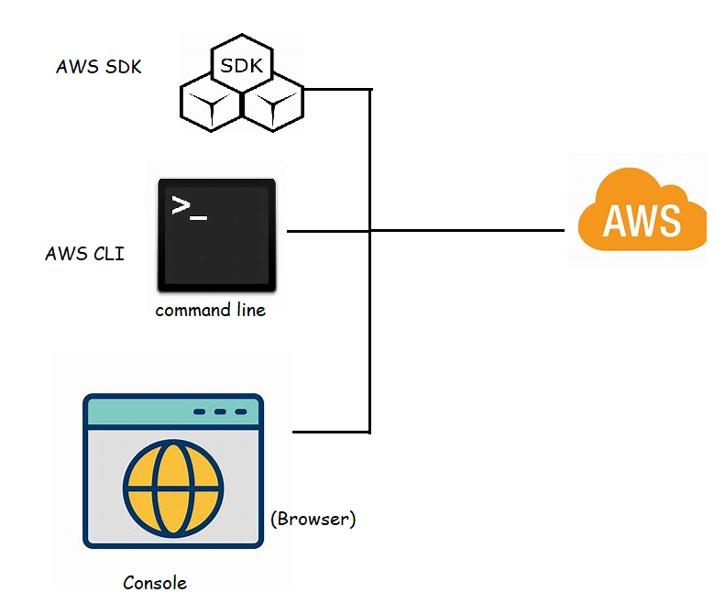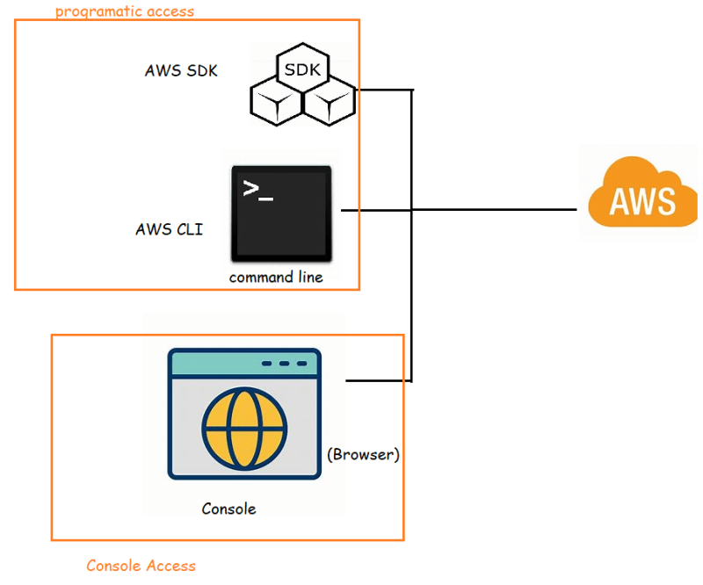

Let’s play with AWS IAM

Login into console <https://console.aws.amazon.com/console/home>

Navigate to IAM 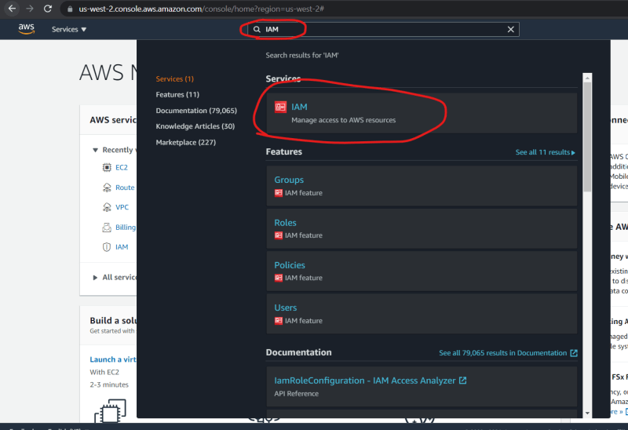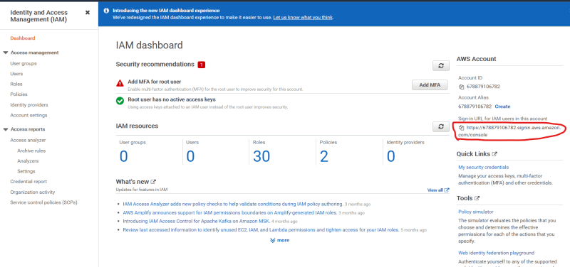

Add user 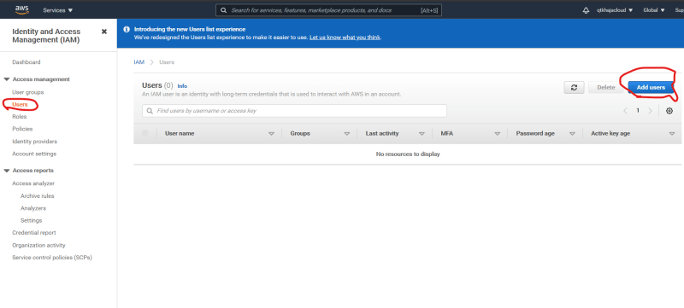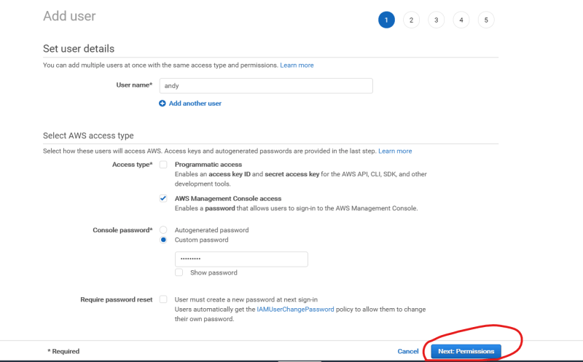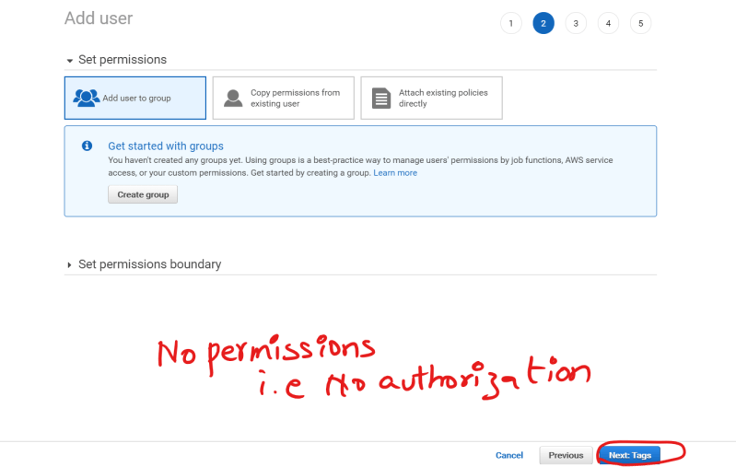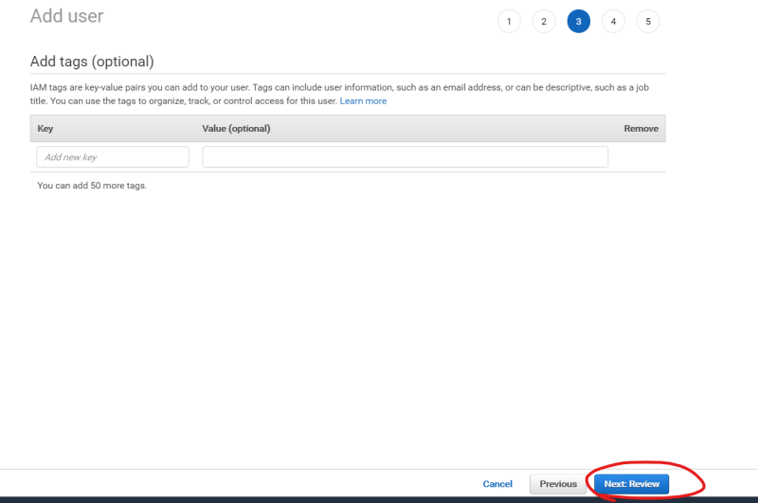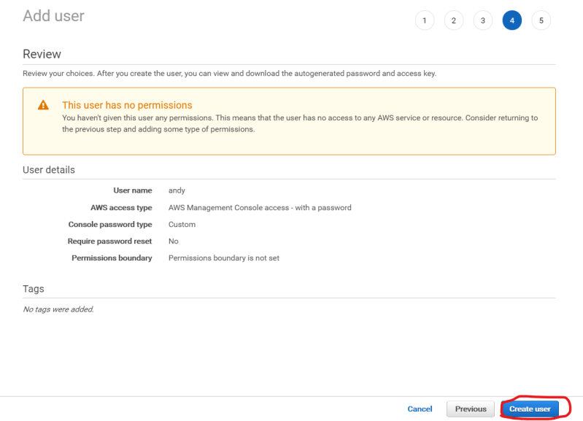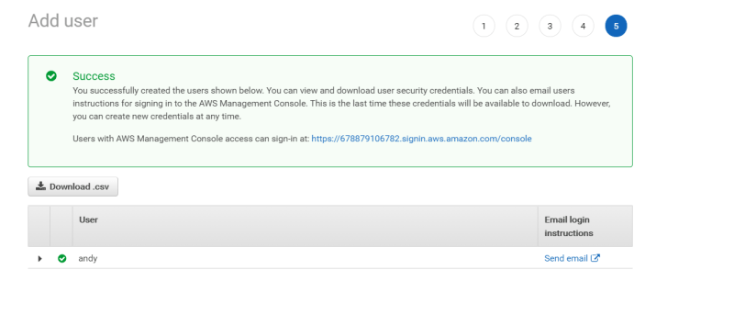

Login as user 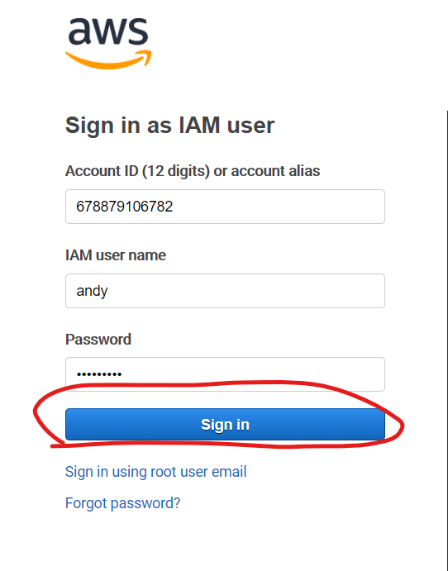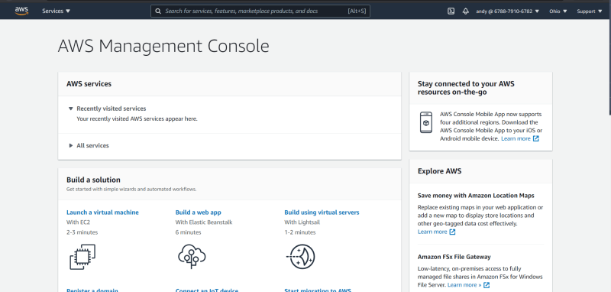

Lets navigate to iam and we should observe authorization/permission issues. 